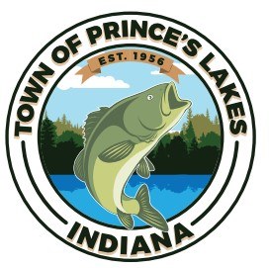
PRINCE’S LAKES TOWN COUNCIL NOTICE OF EXECUTIVE SESSION
The Town Council of the Town of Prince’s Lakes Indiana, at 6:00 p.m. on Monday, December 18, 2023, pursuant to Indiana Code Sections 5-14-1.5-6.1(b)(2)(D), will hold an executive session to discuss strategy with respect to a real property transaction, specifically, a lease.
The executive session will be held at the Prince’s Lakes Town Hall, 14 E. Lakeview Drive, Prince’s Lakes, Indiana, and will be closed to the public.

